CD/DVD Authoring

XBOX

- Make a release build.
- Copy srr2xr.xbe to the cd\xbox folder.
- Rename srr2xr.xbe to default.xbe

CD
Note: XBOX’s are only capable of reading CD-RW media, TDK is recommended.

- Run the XDK utility gdfimage.exe from a command line to create an ISO file.
- syntax is:

gdfimage (source directory) (destination directory\filename.iso)
- Example: c:\gdfimage d:\depot\srr2\cd\xbox d:\burn\srr2_xbox.iso
- Burn the image created at a CD burning station by double clicking on the file, Adaptec Easy CD Creator should open up and begin writing.

DVD General Purpose
Note: A single layered DVD (the DVDs we are capable of burning) will not show the same performance as the dual layered DVDs that the games will be released on. There are however DVD emulators capable of showing real world performance.

- Burn the image created at a DVD burning station (General Purpose) using Prassi DVD burner

DVD Mastering
Note: This is the process for submitting DVDs to Microsoft or other corporations that request this type of layout.

- Run the Xbox Game Disc Layout Tool, this is the XDK command xblayout.exe
- Create a new layout by doing:
  - File\New
  - Point to the directory containing your build project by using the explore window that pops up.
- You may want to view both DVD layers to do this: Views\Both Layers
- Place files according to priority on the DVD layout (Drag and Drop), placing nearest the green boarders will ensure the best performance
- Once the layout has been completed save it by doing a File\Save As
- Take the project directory and the FLD file (the one just made) and archive them all together as a zip.
- Send the archive to the Publisher, where they will create a DLT tape from this layout.

PS2

- If the game is final, then the media will be DVD, ensure radPlatformInit function set in the game.cpp takes as a parameter GameMediaDVD, it will default do GameMediaCD if no parameter is given.
- Make a release build of the game. If this build is to be sent for submission include the mapfile of the release.elf and name it to <product code>.mapfile for example:
SLUS_203.05.mapfile . For SRR2 we compile the game like so

Goto the game\build\ps2 , type the following from a command line
build r clean <cr>
build r <cr>

- ee-strip the srr2pr.elf file that was just generated, this removes addition debug symbols. This utility can be found in the \usr\local\sce\ee\gcc\bin if not in your computers path.

Example: from a command prompt
ee-strip c:\depot\cd\ps2\srr2pr.elf
- Rename the elf to correct product code specified in the system.cnf file. SLPS_123.45 is the default if a valid product code hasn’t been obtained yet (ask your TD, Producer or PS2 Lead if you not sure about the product code )

Typical Product Codes:

US: SLUS_XXX.XX
Europe: SLES_XXX.XX

- Copy CD PS2 folder contents to a burning station (Either Homer or Pipeline-2).

Burning CDS with Flamer.

- Open up a command prompt window.
- Change the root directory to the directory where you copied the CD folder.
- Use flamer utility to burn the CD:
- Example

C:\burn\cd\ps2\ flamer ps2 /HA 2 /ID 2 /nolimits /nomaxfiles /speed 8

Flamer currently only supports up to 8X write-speed

CD/DVD Mastering/General Purpose with CD/DVD-GEN
- Open the Sony supplied tool CD/DVD-Rom Generator ver 1.3
  - Select new project
  - Select DVD-Rom master disk or CD depending on the media type set in your game code.
  - In the open program drag and drop into the directory window (from your built project directory)
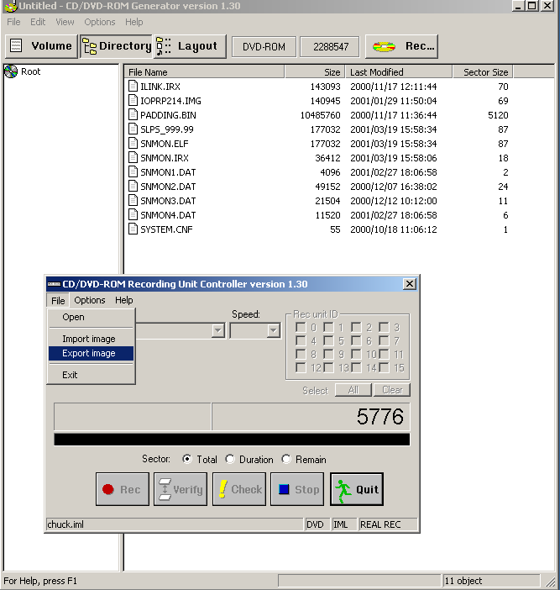
- You may now tweak your layout on the layout tab; best performance will be at the middle of the disk.
- Set region settings by:
  - Options\Preference
  - Set default Area = America
  - Set Disc ID = ON (Changed as of July 2,2002 for all Regions when submitting Mastering DISKS)

- Fill out all information on the Volume tab (this information will be provided by the publisher) SEE PAGE 6 of SONY CD/DVD Burning Manual.
- Hit the record button
  - This will create a my_project.iml and a my_project.ims
  - If you wish to create the master disk hit the record button that appears on the new recorder window for General Purpose DVDs carry on below.
- On the recorder window:
  - File\Export Image
  - This creates a my_project.000 file and a my_project.lst
  - If your game is larger than 1GB multiple my_project.001 , my_project.002, my_project.003, etc will be created. Each being about 1 GB in size roughly.

- If you have a multi-file images then you will need to copy the binaries together like so TO burn to DVD format:

C:\COPY /b my_project.000 + my_project.001+… my_project.00N /b my_project.ISO <CR> => my_project.ISO (only valid for a DVD’s)

If you only have one image file then rename it to <name>.ISO and Burn with Prassi

- Use the CDVD2ISO utility from a command line to convert the my_project.000 file into a valid ISO format to BURN onto CD ONLY . Like so:

C:\cdvd2iso c:\my_project.000 => my_project.ISO

- Burn new ISO with Adaptec Easy CD CREATOR for CD media and Prassi for DVD media.

Game Cube

- Create a release build of game cube with build r command from the game\build\gc folder
- A srr2gr.elf file will be created
- Run this elf file such that a .dlf or Disk Layout File will be generated.
- From a command line run makegcm.exe <source dlf file> <name of gcm>
- Example: C:\makegcm c:\depot\srr2\cd\gc\srr2gr.dlf c:\burn\srr2.gcm
- This creates a Game Cube ISO equivalent file ready to be burned to either cartridge (NPDP) or Mini-DVD (NR-DISK)
- Copy gcm file to Burn Station
- Skip this section if you are NOT making a Submission
- Start Master Editor program
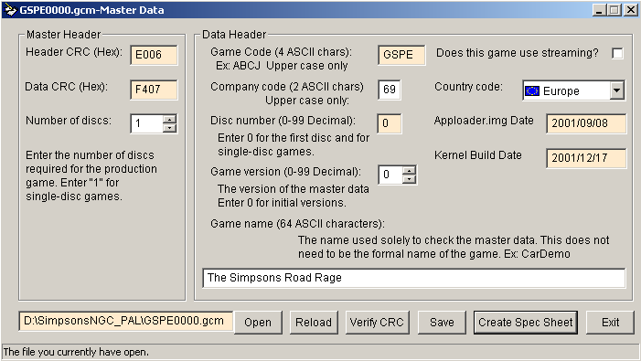

- Click on Open button to load the gcm
- Verify the CRC
- Fill in the fields in white, ask your TD or Producer for the Correct info.
- Save
- Create a spec sheet, and fill in the rest of the fields for this submission build.

BURNING Mini-DVD (NR-DISKS)

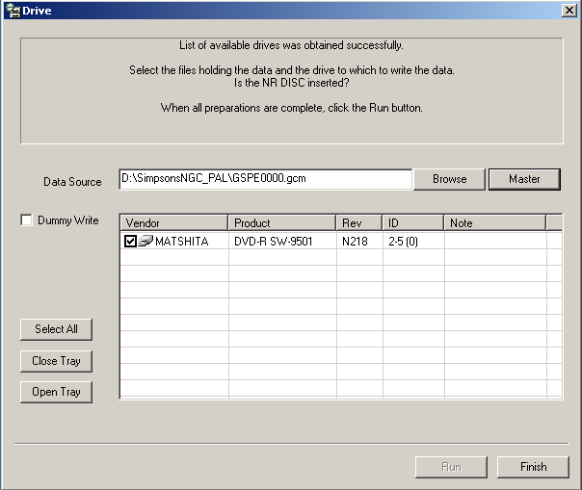

- Run NR-Writer Program
- Click Browse and load gcm
- Click master and check that the encoded header is correct
- Check the DVD-R Burner and Click Run
- TADA one Game Cube Mini-DVD Disk.

BURNING NPDP CARTRIDGES

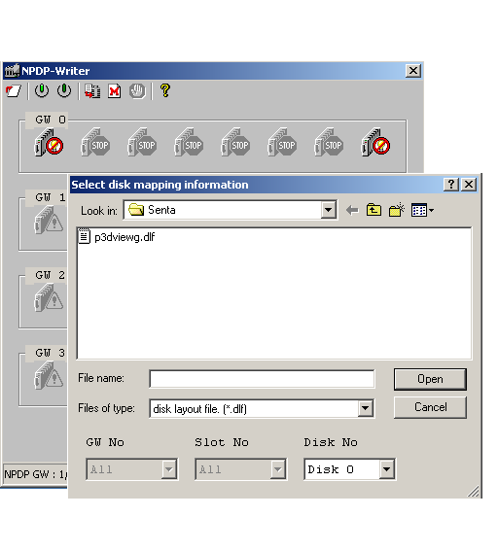

- Insert cartridge into the NPDP- WRITER
- Open the NPDP-Writer Program
- Click on the cart icon that you want to burn to (you can burn up to 8 carts at once)
- Notice that now the circle in the cart Icon will change from red to green
- The Cartridge is now powered up. DO NOT REMOVE THE CARTRIDGE WHILE IT’S POWERED UP.
- Choose the write to all from the tool bar
- Select gcm from the files of type in the new dialog window
- Browse and load gcm
- Cartridge will now burn
- Click on the green cart Icon to power it OFF
- Remove Cartridge from NPDP-Writer

